Part Number: PTR13-89150

PTR13-89160

Kit Contents
Item # | Quantity Reqd. | Description
1 | 2 | Coil / Shock Assembly
2 | 2 | Shock, Rear
3 | 2 | Hardware Bag
Hardware Bag #1 Contents
Item # | Quantity Reqd. | Description
1 | 2 | Reservoir Bracket
2 | 2 | Reservoir Bracket Adapter
3 | 2 | Right-Angle Stud, 1/4"-20 x 3/4", 18-8 Stainless
4 | 2 | Retaining Washer
5 | 2 | Washer
6 | 6 | Split Lock Washer, For M8 SHCS, 18-8 Stainless
7 | 6 | Socket Head Cap Screw, M8x1.25, L=25mm, 18-8 Stainless
8 | 2 | Split Lock Washer, For 1/4" Screw, 18-8 Stainless
9 | 2 | Thin Hex Locknut, 1/4"-20, Nylon Insert, 18-8 Stainless
10 | 2 | Socket Head Cap Screw, M6x1, L=25mm, 18-8 Stainless
11 | 2 | Retaining Ring, Reservoir
Hardware Bag #2 Contents
Item # | Quantity Reqd. | Description
1 | 2 | Alignment Cushion, Upper Stem Mount
2 | 4 | Locknut, M12x1.25
Additional Items Required For Installation
Item # | Quantity Reqd. | Description
General Applicability
4Runner MY2010 and newer
Conflicts
4Runner equipped with X-REAS and/or KDSS
Recommended Sequence of Application
Item # | Accessory
1 | TRD Suspension
2 | TRD Skid Plate
3 | TRD Wheel / Tire Assemblies
*Mandatory
Recommended Tools
Personal & Vehicle Protection | Notes
Special Tools | Notes
Alignment Equipment | Turn plates needed
Paint Marker | To mark the alignment cam position
Installation Tools | Notes
Sockets | 10mm, 11mm, 12mm, 14mm, 17mm, 19mm, 21mm & 22mm
Hex Sockets | 5mm & 6mm
Ratchet | 3/8” & 1/2”
Crowfoot | 14mm, 18mm & 22mm
Wrench | 18mm, 19mm & 22mm
Ratcheting Wrench | 14mm & 17mm
Adjustable Wrench | Regular & small
Torque Wrench | 3/8” & 1/2"
Screw Driver | Long Phillips
Air tools | NOTE: Do not use for final assembly
Clip Removal Tool
Tape
Special Chemicals | Notes
Medium Strength Thread Locker | Permatex® BLUE Gel
Vehicle Service Parts (may be required for reassembly)
Item # | Quantity Reqd. | Description
Legend
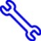
STOP: Damage to the vehicle may occur. Do not proceed until process has been complied with.
OPERATOR SAFETY: Use caution to avoid risk of injury.
CAUTION: A process that must be carefully observed in order to reduce the risk of damage to the accessory/vehicle and to ensure a quality installation.
TOOLS & EQUIPMENT: Used in Figures calls out the specific tools and equipment recommended for this process.
REVISION MARK: This mark highlights a change in installation with respect to previous issue.
SAFETY TORQUE: This mark indicates that torque is related to safety.

Care must be taken when installing this accessory to ensure damage does not occur to the vehicle. The installation of this accessory should follow approved guidelines to ensure a quality installation.

These guidelines can be found in the "Accessory Installation Practices" document.

This document covers such items as:-
- Vehicle Protection (use of covers and blankets, cleaning chemicals, etc.).
- Safety (eye protection, rechecking torque procedure, etc.).
- Vehicle Disassembly/Reassembly (panel removal, part storage, etc.).
- Electrical Component Disassembly/Reassembly (battery disconnection, connector removal, etc.).

Please see your Toyota dealer for a copy of this document.

Remove the Front OE Shock Assemblies.
  - Place the vehicle in Park (AT) or in gear (MT).
  - Put a brake hold tool in place.
  - Raise the vehicle.
  - Remove the front wheels.
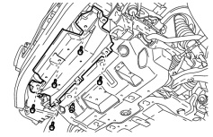
  - Remove the clip (circled), 5 bolts and the front lower bumper cover (Fig. 1-1).
Fig. 1-1
10mm socket, ratchet & clip removal tool

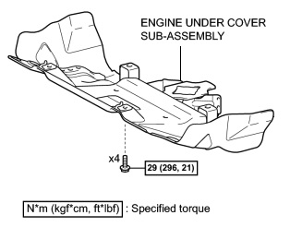
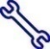
  - Use a 12mm socket to remove the four bolts from the engine under cover sub-assembly (Fig. 1-2). Remove the cover and retain it and the bolts for reinstallation.
Fig. 1-2
12mm socket & ratchet
NOTE: Dispose of the front lower bumper cover, engine under cover and fasteners IF working with a TRD PRO vehicle. They will not be reused and will be replaced with the TRD Skid Plate.

  - Remove the front shock absorber with coil spring assembly.
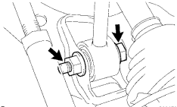
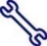
    - Use a 19mm wrench and 19mm socket to remove the lower bolt, nut and washer (Fig. 1-3). Retain them for reinstallation.
Fig. 1-3
19mm wrench, 19mm socket & ratchet
HINT: Push down on the brake caliper slightly to allow the bolt to slide out.

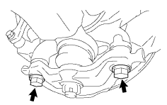
    - Use a 19mm socket to remove the two bolts from the lower ball joint assembly (Fig. 1-4). Retain them for reinstallation.
Fig. 1-4
19mm socket & ratchet

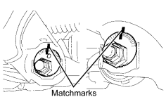
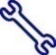
    - Place matchmarks at the top of the front and rear alignment cams to indicate the original position before loosening them. This will provide a point of reference. (Fig. 1-5).
Fig. 1-5
Marker, 22mm socket & ratchet

    - Use a 22mm socket to loosen (do not remove) the lower control arm cam bolts & nuts to allow the lower control arm to swing down freely.
        - At the front of the arm, loosen the bolt head facing forward.
        - At the rear of the arm, loosen the nut facing rearward.

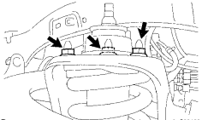
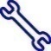
    - Use a 14mm ratcheting wrench to remove the three nuts on the upper side of the OE front shock absorber with coil spring assembly (Fig. 1-5). Remove the assembly from the vehicle.
Fig. 1-5
14mm ratcheting wrench
CAUTION: Take care not to damage the axle CV boot or steering rack boot while lowering the assembly.

Install the TRD Shock Absorber Assembly.
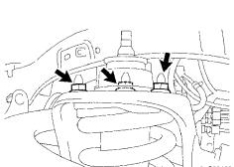
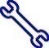
  - With the TRD logo facing out, use a 14mm ratcheting wrench to temporarily install the three nuts onto the upper side of the front shock absorber with coil spring assembly (Fig. 2-1).
Fig. 2-1
14mm ratcheting wrench, torque wrench & crowfoot
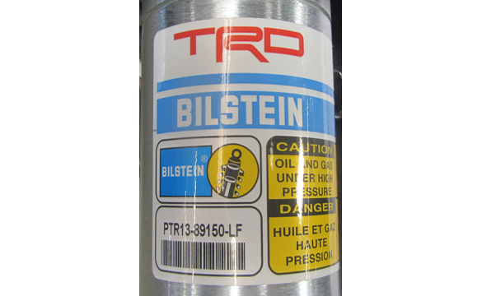
NOTE: The shock absorbers are labeled LF & RF (circle, Fig. 2-2). Ensure the proper unit is installed on the correct side of the vehicle.
Fig. 2-2
  - Align the lower shock mount to the lower control arm, then raise the lower control arm and assemble it to the lower shock mount.

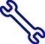
  - Use a 19mm wrench and a 19mm socket to temporarily tighten the lower bolt, nut and washer as shown in Fig. 2-3.
Fig. 2-3
19mm wrench & socket
NOTE: Hand tighten for moving the vehicle to alignment.
  - Use a 14mm crowfoot to torque the three nuts on the upper side of the front shock absorber with coil spring assembly (Refer to Fig. 2-1).

Torque, with crowfoot:

65 N·m (663 kgf·cm, 48 ft·lbf)

Torque, without crowfoot:

71 N·m (724 kgf·cm, 52 ft·lbf)
  - Push down on the steering knuckle so that it aligns with the lower ball joint assembly.
  - Use a 19mm socket to install and torque the front lower ball joint attachment with the two bolts (Fig. 2-4).
Fig. 2-4
19mm socket & torque wrench

WARNING: You MUST hand start these bolts before using an air tool.

Torque: 160 N·m (1631 kgf·cm, 118 ft·lbf)

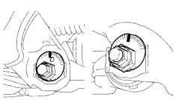
  - Align the adjustment cams to the marks made in Step 1(g)(3) (Fig. 2-5).
Fig. 2-5
22mm socket & ratchet
  - Use a 22mm socket to temporarily tighten the lower control arm bolts (Fig. 2-5). Snug with a ratchet is fine until alignment.

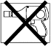
  - Install the front wheel/tire assemblies onto the vehicle. Hand start the lug nuts during installation. Tighten the lug nuts in sequence 1 through 6 or equivalent star pattern (Fig. 2-6). Ensure that the socket does not scuff the wheels. Tighten to 113 N-m (83 ft-lbf) using a torque wrench.

Fig. 2-6
Torque 2 Cycles
(All Lugs/Locks)
2x
A1
A2
A3
A4
A5
A6
Torque: 113 N·m (1,152 kgf·cm, 83ft·lbf)
  - Re-torque all lug nuts in the same 1-6 sequence (Fig. 2-6).
Torque: 113 N·m (1,152 kgf·cm, 83ft·lbf)
CAUTION: DO NOT USE AN IMPACT WRENCH TO INSTALL OR REMOVE WHEEL LOCKS.
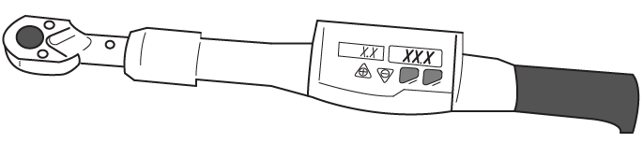
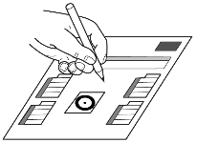
  - With the vehicle still on the lift, use a digital torque wrench to measure the torque of each lug nut/lock and record it on the Torque Audit Sheet (Fig. 2-7). (PPO installation only. Does not apply to DIO installation.)

Fig. 2-7
Measure Torque and Document
(All Lugs/Locks)
A1
A2
A3
A4
A5
A6

Remove the Rear OE shocks.
  - Remove the rear wheels.
  - Support the rear axle housing using a tall stand or a floor jack if working low to the ground.

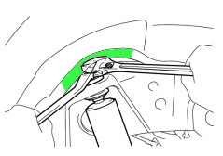
  - Apply tape in the indicated area and use a 17mm ratcheting wrench to remove the nut while keeping the piston rod from rotating with an adjustable wrench (Fig. 3-1).
Fig. 3-1
Tape, 17mm ratcheting wrench & small adjustable wrench
  - Remove the nut, upper cushion and retainer.
      - Retain the upper cushion and retainer.
      - The nut will not be reused.

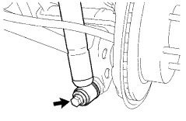
  - Use a 17mm socket to remove the lower shock absorber bolt and separate the shock absorber (Fig. 3-2).
Fig. 3-2
17mm socket & ratchet

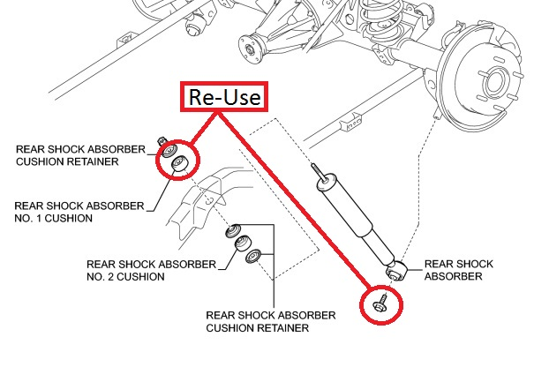
  - Retain the cushion retainer, top cushion and lower bolt (Fig. 3-3).
Fig. 3-3
  - Discard the nut, lower cushion and shock absorber.

Install the Reservoir Bracket Adapter.
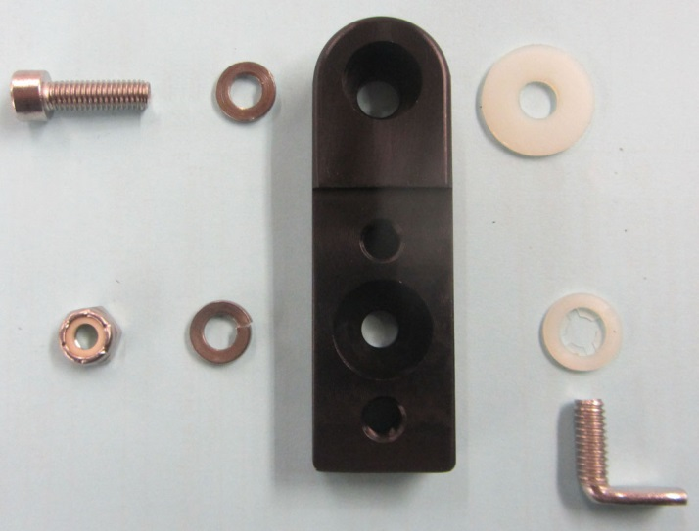
  - Lay out the reservoir bracket adapter and hardware for each side (Fig. 4-1).
4
3
1
2
7
8
6
5
Fig. 4-1
    - M8 SHCS
    - Split lock washer for M8 SHCS
    - Reservoir bracket adapter
    - Nylon washer
    - ¼” thin hex locknut, nylon
    - Split lock washer for ¼”
    - Nylon retaining washer
    - Right angle weld stud
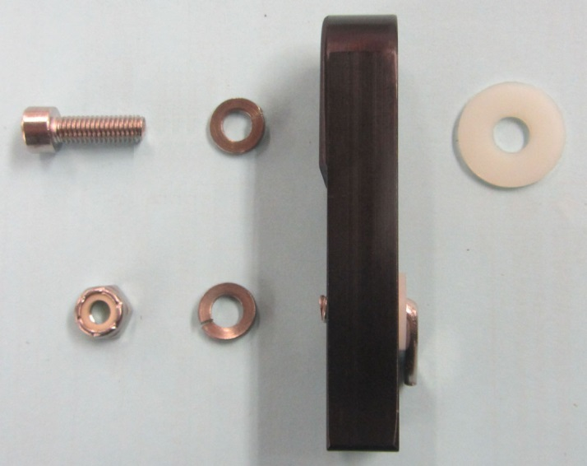
  - Slide the nylon retaining washer over the right angle weld stud, and then insert the threaded end of the stud into the reservoir bracket adapter (Fig. 4-2).
Fig. 4-2
NOTE: Be sure to insert the weld stud into the smooth side of the bracket adapter.

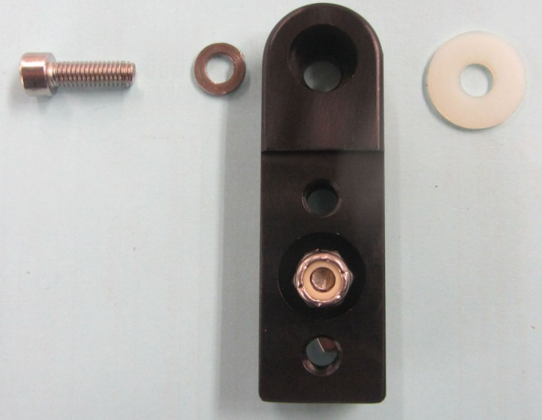
  - Slide a split lock washer for ¼” over the right angle weld stud, and then thread on the ¼” thin hex nylon locknut by hand until the threads of the right angle weld stud reach the nylon in the locknut (Fig. 4-3).
Fig. 4-3
NOTE: Be sure to fit the locknut into the counter bore of the bracket adapter.

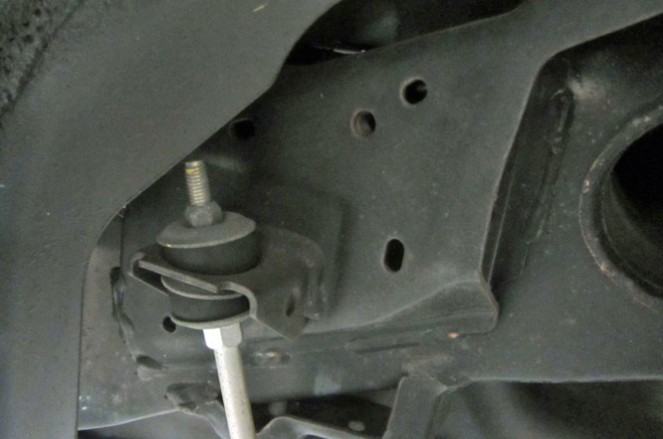
  - Locate the slot on the chassis in Fig. 4-4.
Fig. 4-4
NOTE: Driver’s side shown. Use the sway bar end link attachment for reference.

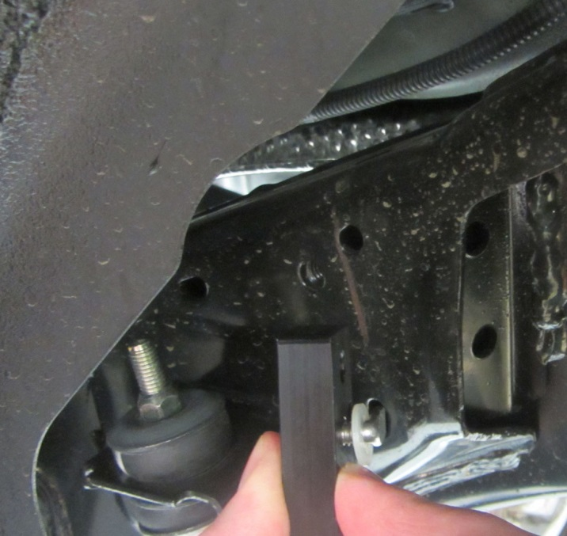
  - With the reservoir bracket adapter hanging upside down, slide the right angle weld stud into the slot located in Step 5(d) (Fig. 4-5).
Fig. 4-5
NOTE: Orient the tab such that it angles towards the front of the vehicle as it enters the slot.

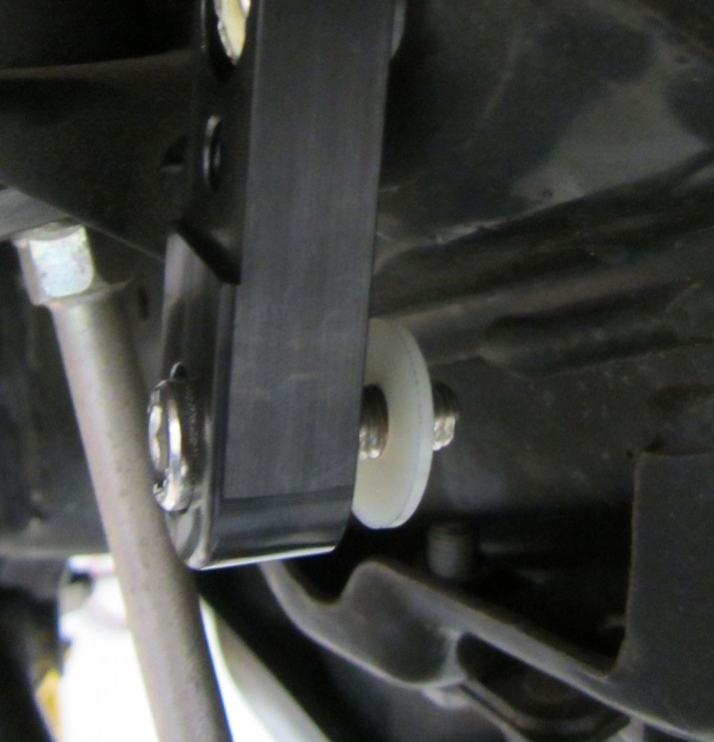
  - With the reservoir bracket adapter hanging upside down, slide the M8 SHCS through a split lock washer for M8 SHCS, and then into the remaining countersunk hole (Fig. 4-6).
Fig. 4-6
  - Slide the nylon washer over the exposed thread of the M8 SHCS (Fig. 4-6).
  - Apply Permatex Blue Gel to the exposed M8 threads.

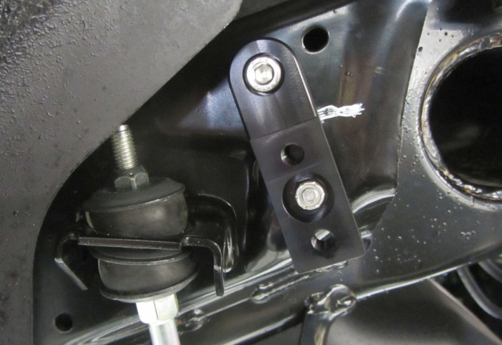
  - Swing the reservoir bracket adapter right side up and torque the M8 SHCS into the threaded hole in the chassis using a 6mm hex socket (top, Fig. 4-7).
Fig. 4-7
6mm hex, 11mm socket & torque wrench

Torque: 18 N·m (184 kgf·cm, 13ftn·lbf)
  - Use an 11mm socket to torque the ¼” nut (bottom, Fig. 4-7).

Torque: 7 N·m (72 kgf·cm, 62 in·lbf)

Install the Reservoir Bracket.
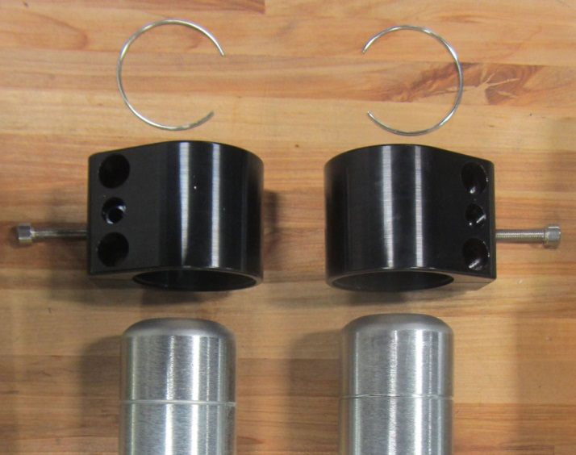
  - Lay out the reservoir bracket and the appropriate hardware for each side (Fig. 5-1).
Fig. 5-1
Driver’s Side
Passenger’s Side
NOTE: The driver’s side is on the left and the passenger’s side is on the right.
    - Snap ring.
    - M6 SHCS.
    - Reservoir bracket.
NOTE: The stepped side of the bracket is facing down as it will mate with the bracket adaptor installed in Step 5. This orientation is critical.

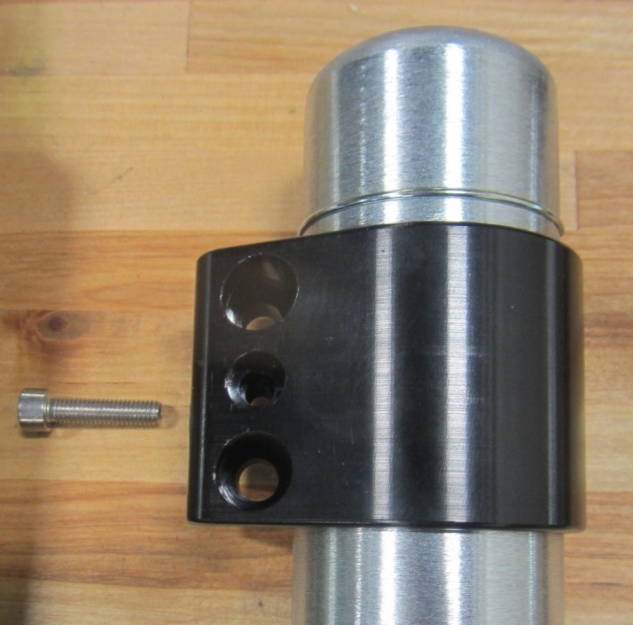
  - Slide the reservoir bracket down over the reservoir tube then install the snap ring into the groove (Fig. 5-2).
Fig. 5-2
NOTE: Confirm the snap ring is completely seated in the groove.

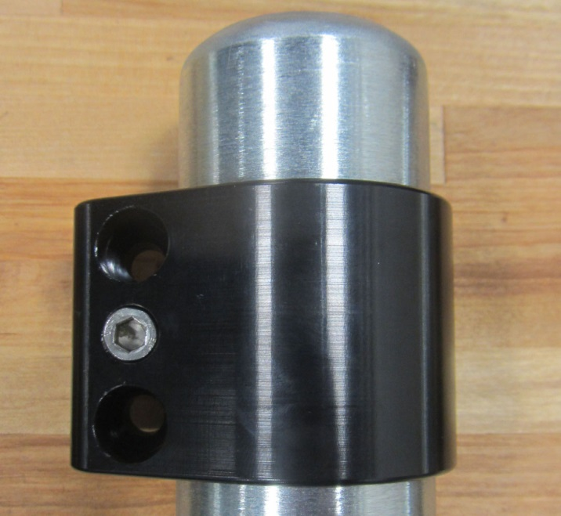
  - Slide the reservoir bracket up over the snap ring until it bottoms out (Fig. 5-3).
Fig. 5-3
5mm hex
  - Apply Permatex Blue Gel to M6 SHCS.
  - Use a 5mm hex socket to torque the M6 SHCS.
Torque: 7 N·m (72 kgf·cm, 62 in·lbf)

Install the TRD Rear Shock Absorbers.
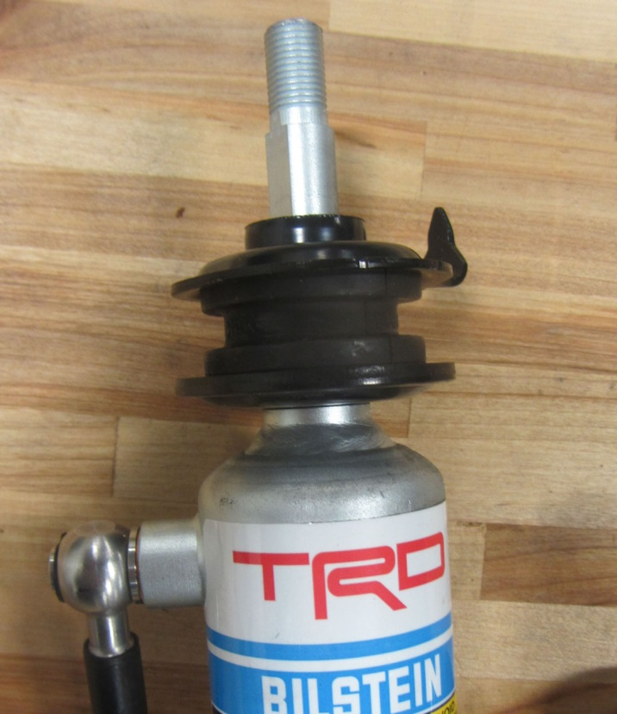
  - Install a new supplied alignment cushion onto the shock stud. Make sure that the alignment stake is pointed away from the hose bung (Fig. 6-1).
Fig. 6-1
Front
Back
RH Pictured

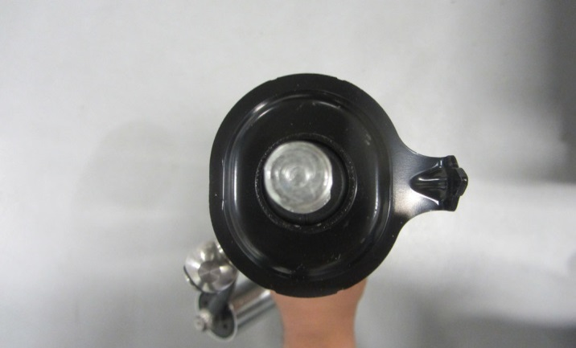
  - Identify the left and right shock absorbers. The reservoir hose bung points OUT from the centerline of the vehicle, towards the installer (RH shown, Fig. 6-2). This orientation is critical.
Fig. 6-2
RH Pictured
Front
Centerline
Bung

  - Use a 17mm socket to temporarily install the shock absorber lower mount with the bolt removed in Step 3(e) (Fig. 6-3).
Fig. 6-3
17mm socket & ratchet

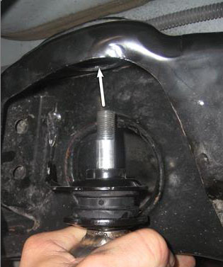
  - Insert the stud into chassis shock mount (Fig. 6-4).
Fig. 6-4
Front
NOTE: To fit the shock absorber, SLOWLY compress it making sure to press perfectly in line with the shock shaft. Any pressure off axis will make it very difficult to compress.

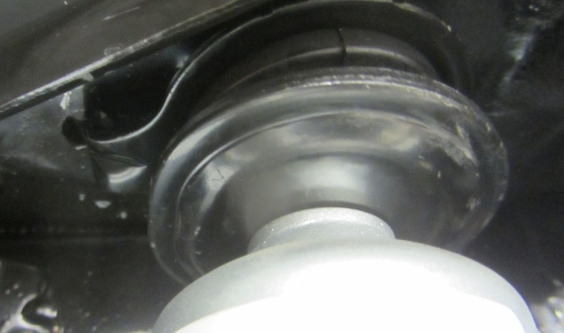
  - Ensure that the shock stud and alignment cushion is centered properly in the chassis shock mount, and the alignment stake is located in the hole directly forward of the shock stud hole (Fig. 6-5).
Fig. 6-5
Front

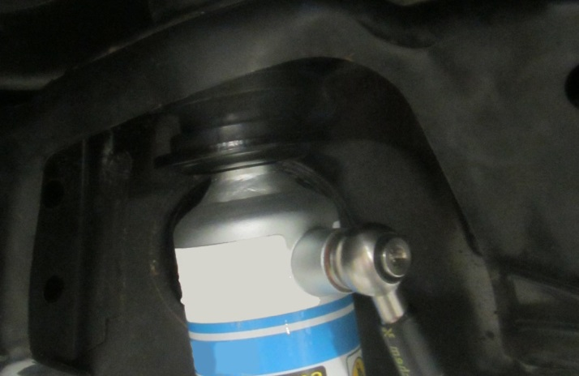
  - Make sure that once installed, the hose bung is pointed outboard from the center, and towards the rear of the vehicle (Fig. 6-6).
Fig. 6-6
Rear

  - Reinstall the upper cushion and retainer onto the shock stud and tighten the new supplied nut (Fig. 6-7).
Fig. 6-7
18mm crowfoot & torque wrench
Torque: 25 N·m (255 kgf·cm, 18 ft·lbf)

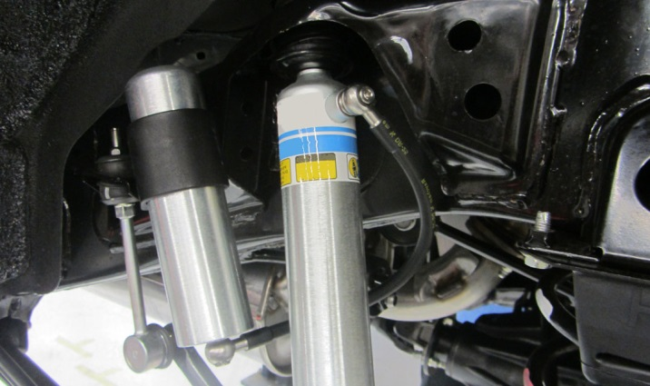
  - With the main shock body in place, route the reservoir and reservoir hose toward the center of the vehicle, behind the main shock body, then towards the front of the vehicle (Fig. 6-8).
Fig. 6-8
Rear
  - Slide two M8 SHCS through two split lock washers for M8 SHCS, then through the two holes in the reservoir bracket.
  - Apply Permatex Blue Gel to the exposed threads of the M8 SHCS.
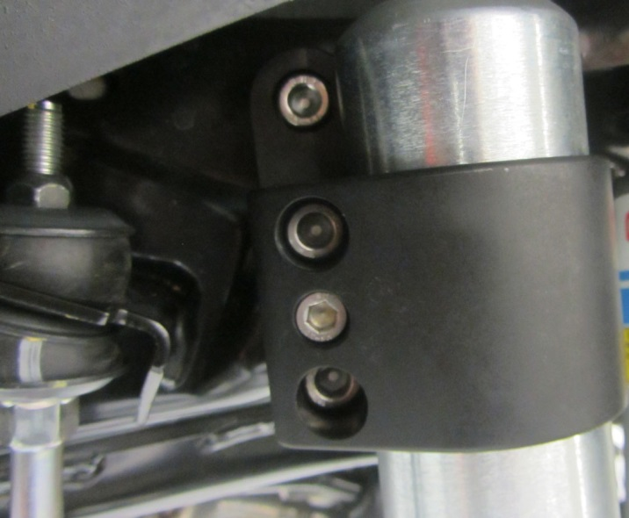
  - Use a 6mm hex socket to secure the reservoir bracket to the reservoir bracket adapter (Fig. 6-9).
Fig. 6-9
6mm hex socket & torque wrench
Torque: 17 N·m (173 kgf·cm, 13 ft·lbf)
CAUTION: After torqueing, ensure the reservoir hose bung is pointed away from the frame and not contacting any part of the vehicle. This is especially important on the driver’s side.

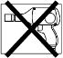
  - Install the rear wheel/tire assemblies onto the vehicle. Hand start the lug nuts during installation. Tighten the lug nuts in sequence 1 through 6 or equivalent star pattern (Fig. 6-10). Ensure that the socket does not scuff the wheels. Tighten to 83 ft-lbf (113 N-m) using a torque wrench.

Fig. 6-10
Torque 2 Cycles
(All Lugs/Locks)
2x
A1
A2
A3
A4
A5
A6
Torque: 113 N·m (1,152 kgf·cm, 83ft·lbf)
  - Re-torque all lug nuts in the same 1-6 sequence (Fig. 6-10).
Torque: 113 N·m (1,152 kgf·cm, 83ft·lbf)
CAUTION: DO NOT USE AN IMPACT WRENCH TO INSTALL OR REMOVE WHEEL LOCKS.
  - With the vehicle still on the lift, use a digital torque wrench to measure the torque of each lug nut/lock and record it on the Torque Audit Sheet (Fig. 6-11). (PPO installation only. Does not apply to DIO installation).

Fig. 6-11
Measure Torque and Document
(All Lugs/Locks)
A1
A2
A3
A4
A5
A6

Adjust the Wheel Alignment.
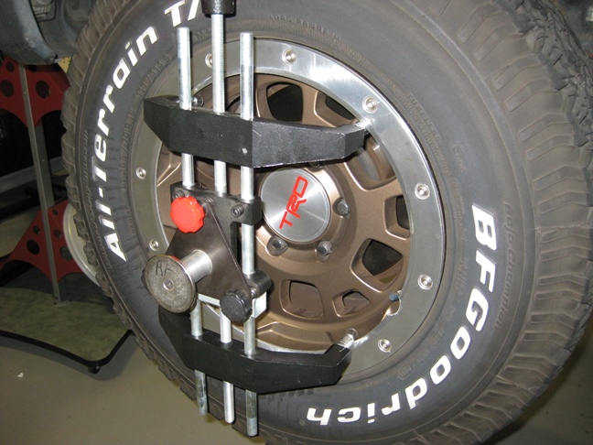
  - Install the wheel clamps (Fig. 7-1).
Fig. 7-1
Valve stem relief area
    - When aligning vehicle using standard wheel clamps, be sure to align vehicle with the original steel or aluminum wheels.
    - When aligning vehicle using a wheel clamp that grips the tire, the new TRD wheel / tire assemblies can be used.
NOTE: The purpose of this differentiation is to help prevent paint damage on the new wheels.

Measure/Adjust the Camber, Caster and Standard Steering Axis Inclination.
Alignment Settings

Camber: -0°1' +/-30' (-0.02° +/-0.5°)
- Caster: 3°15' +/-30' (3.25° +/-0.5°)
- Cross camber and cross caster difference should be 30' (0.5°) or less.
- Standard Steering Axis Inclination: 12°11' +/-30' (12.18° +/-0.5°)
- Toe-in: A + B: 0°10' +/-0°9' (0.16° +/-0.15°) and C - D: 2.29 +/-2 mm (0.09 +/-0.08 in.)

Camber: -0°1' +/-30' (-0.02° +/-0.5°)
Caster: 3°15' +/-30' (3.25° +/-0.5°)
Standard Steering Axis Inclination: 12°11' +/-30' (12.18° +/-0.5°)

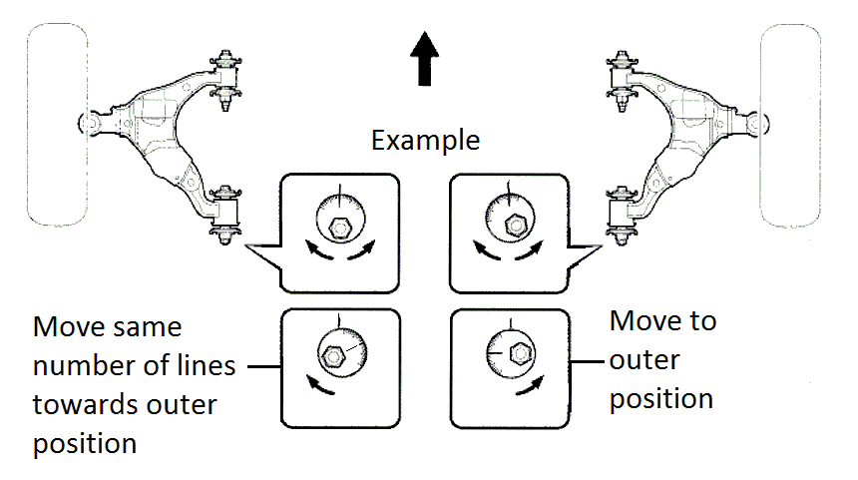
  - Rotate the front and rear adjustment cams to get as close as possible to the nominal specifications listed above (Fig. 8-1).
Fig. 8-1
NOTE: Cross camber and cross caster difference should be 30' (0.5°) or less. Having the left and right side numbers match is more critical than getting the measured value to the nominal specification.
NOTE: Caster can only be measured while a brake hold tool is in place applying the brakes.
  - Use a 22mm socket to torque the front and rear lower control arm bolts (Fig. 8-2).
Fig. 8-2
22mm socket & torque wrench

Torque: 175 N·m (1785 kgf·cm, 129 ft·lbf)

Measure/Adjust the Toe-In.

Toe-in: A + B: 0°10' +/-0°9' (0.16° +/-0.15°) C - D: 2.29 +/-2 mm (0.09 +/-0.08 in.)
  - Install a steering wheel holding tool. Insure that the steering wheel is completely straight.
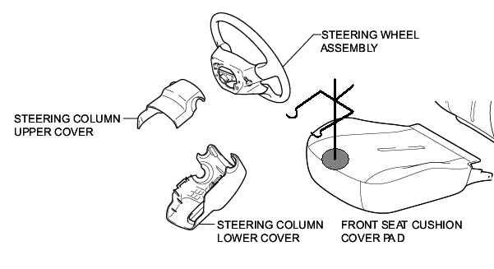
HINT: Line up the horn pad with the plastic garnish covering the steering column (Fig. 9-1).
Fig. 9-1

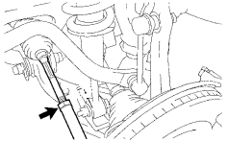
  - Use a 22mm crowfoot to torque the locking nut and be sure not to upset the final readings (Fig. 9-2).
Fig. 9-2
22mm crowfoot & torque wrench

Torque: 88 N·m (897 kgf·cm, 65 ft·lbf)
  - Remove the alignment heads and return them to the cart.
  - Remove the wheel clamps.

  - Use a 19mm wrench and 19mm socket to torque the front lower shock bolts (Fig. 9-3).
Fig. 9-3
19mm socket, 19mm wrench & torque wrench

Torque: 95 N·m (969 kgf·cm, 70 ft·lbf)

  - Use a 12mm socket to install the engine under cover and torque the bolts (Fig. 9-4).
Fig. 9-4
12mm socket and torque wrench

Torque: 29 N·m (296 kgf·cm, 21 ft·lbf)
NOTE: If the vehicle will be outfitted with the TRD Skid Plate, do not install the factory engine under cover or front lower bumper cover and install the TRD Skid Plate now.

  - Replace the 5 bolts and clip (circled) in the front lower bumper cover (Fig. 2-9).
Fig. 9-5
10mm socket & torque wrench

  - Use a 17mm socket to torque the rear lower shock bolts (Fig. 9-6).
Fig. 9-6
17mm socket & torque wrench

Torque: 98 N·m (1000 kgf·cm, 72 ft·lbf)

Adjust the Vertical Headlamp Aim.
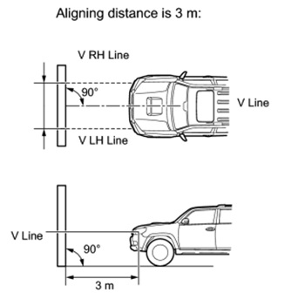
  - Prepare the vehicle in accordance with the following conditions (Fig. 10-1):
Fig. 10-1
    - Place the vehicle in a location that is dark enough to clearly observe the cutoff line. The cutoff line is a distinct line, below which light from the headlights can be observed and above which it cannot.
    - Place the vehicle at a 90° angle to the wall.
    - Keep a 3 m (9.84 ft) distance between the center of the headlight bulb and the wall.
    - Place the vehicle on a level surface.
    - Measure the height to the center mark on the headlight lens. This is your H Line height.
    - Mark this height on the wall in front of the vehicle (ex: use masking tape).

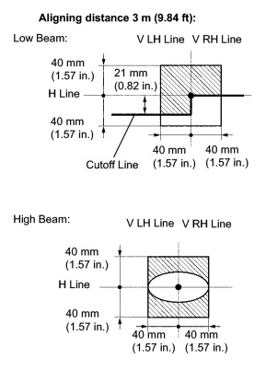
  - Adjust the vertical aim of the lamps (Fig. 10-2).
Fig. 10-2
    - Cover the headlight on the opposite side to prevent light from the headlight not being adjusted from affecting the headlight aiming process.
NOTICE: Do not keep the headlight covered for more than 3 minutes. The headlight cover can be damaged due to high heat.
    - Turn on the headlamps.

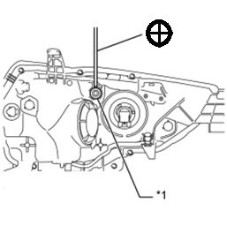
    - Adjust the headlight aim to within the specified range by turning aiming screw “V” with a screwdriver (Fig 10-3).
Fig. 10-3
Phillips screwdriver
NOTE: The final turn with the screwdriver should be in the clockwise direction. If you pass the correct adjustment point, loosen the screw and then retighten it, so that the final turn of the screw is in the clockwise direction.
NOTE: Since the low-beam light and the high-beam light are a unit, if the aim on one is correct, the other should be correct. The high-beam should only need verification and no adjustment, but check and adjust if necessary.

Accessory Function Checks
Verify the rear shock hoses orientation.

Confirm the rear shock reservoir mounting.

Vehicle Function Checks
Check the steering wheel.
Verify the headlight aim.
The rear shock hoses should face away from the frame and to the rear of the vehicle.
The rear shock reservoirs should be fixed in place

The steering wheel should be straight.
The headlight aim should be in spec.

Vehicle Appearance Check
After accessory installation and removal of protective cover(s), perform a visual inspection.

Ensure no damage (including scuffs and scratches) was caused during the installation process.
(For PPO installations, refer to TMS Accessory Quality Shipping Standard.)

